Database Systems Engineering and Distributed Backend Development(25CS1302E)

PRACTICAL WEEK – 1

- Connect to the MySQL Server
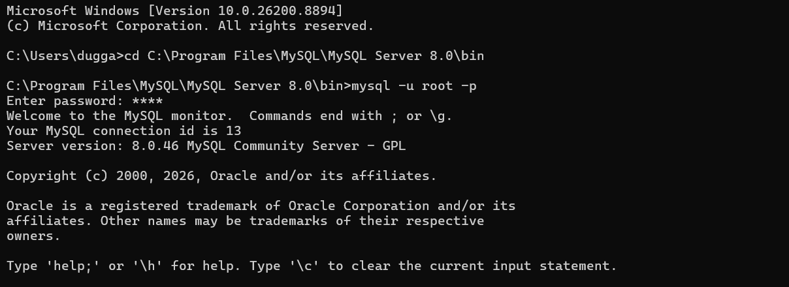
- Create a Database
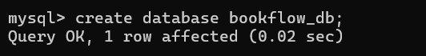
- Select the Database
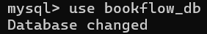
- Create the books Table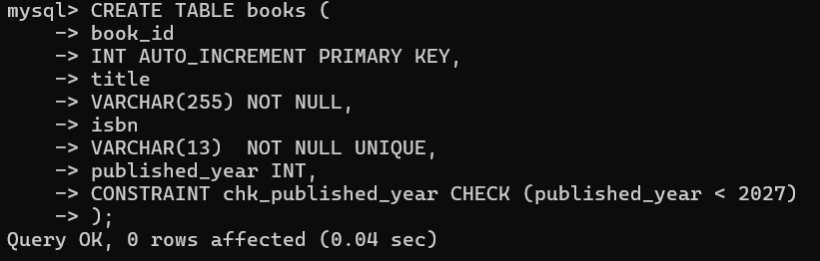
- Create the members Table
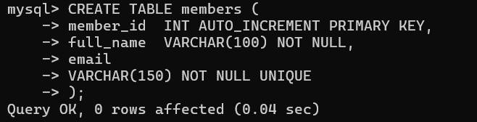
- Verify the Table Structure
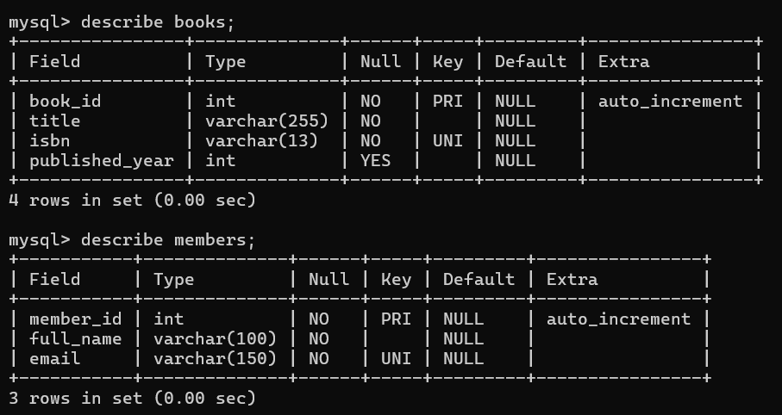

- Insert Data into the books Table
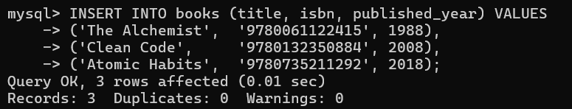
- Insert Data into the members Table
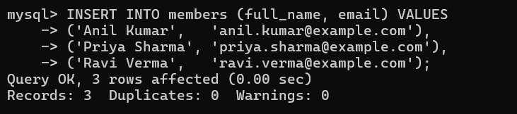
- Display the Table Data
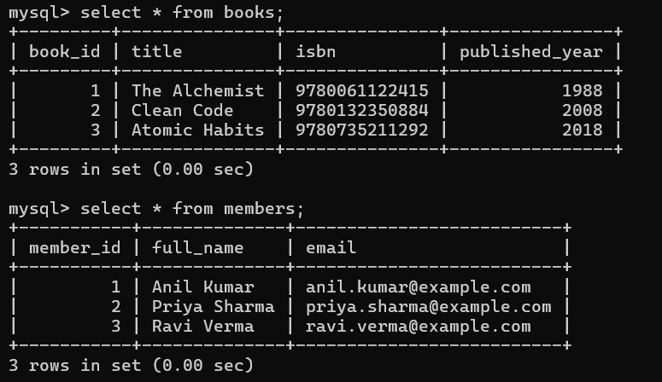

- Update Book IDs
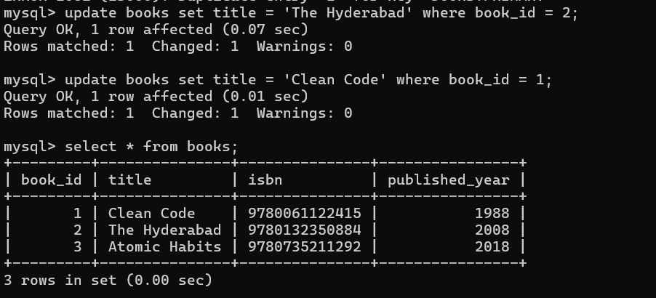
- Update Member IDs
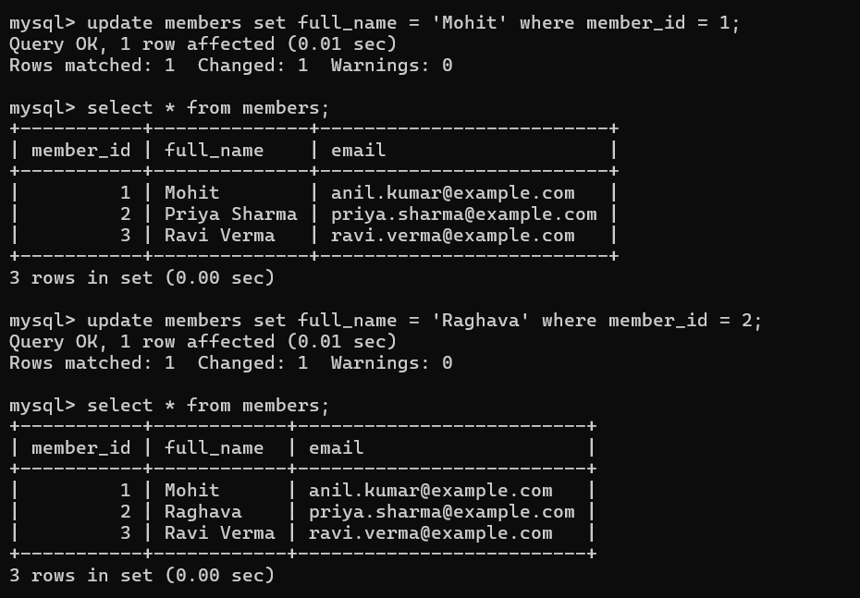

- Constraint Tests (These MUST Fail):
1: Duplicate ISBN (UNIQUE violation)
2: NULL title (NOT NULL violation)
3: Future publication year (CHECK violation)
4: Duplicate email (UNIQUE violation)

Final Output:
